**Soft-skills**

**Semester-4**

**Notes- Module 3 & 4**

Personal Effectiveness

**Define Personal Effectiveness:**

Getting the best out of YOURSELF. It is an approach to success that involves utilizing all your energy, skills and motivation to develop and reach the goals you set for yourself.

**Importance of Personal Effectiveness:**

Enhances performance

Helps in achieving the desired result

Helps to work towards personal goals

Develop personal strategies for coping

Overall wellness

Helps to develop and maintain relationships

**

Self Esteem is how we Value and perceive ourselves.

One’s worth or abilities

Beliefs about self

Emotional state (victory, despair)

What lowers your Self – Esteem

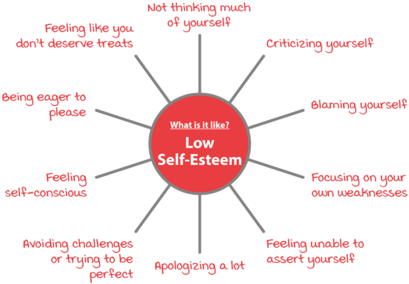

Maslow’s Hierarchy of Needs:

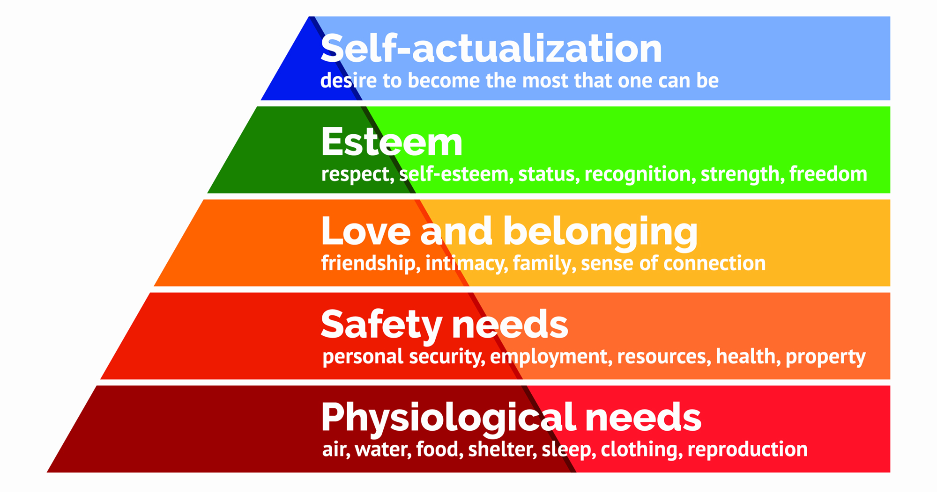

Building your Self Esteem:

Take care of your physical needs

Hang out with people who understand you

Forgive your own past mistakes

Smile, accept compliments

Enjoy some “me time”

You can have a different opinion

Recognize and appreciate of your accomplishments

It is ok to be imperfectly perfect!

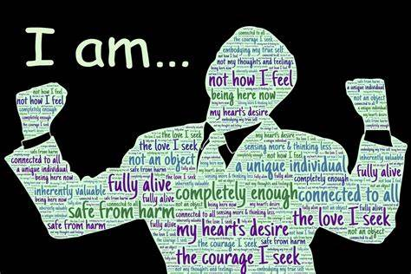

***It is not your Job to love me, It is MINE.***

Assertiveness as a Skill:

Assertiveness is a social skill relying on effective communication. An assertive person respectfully and clearly communicates their needs, wants, position and boundaries to people. It gives you the freedom to be yourself without being disrespectful to others.

**Accountability:**

An acceptance of responsibility for honest and ethical conduct towards others can be defined as accountability.

4 Pillars of Accountability:

Responsibility: “ a duty that binds to the course of action.”

Answerability : “ being called to account”

Trustworthiness: “ a trait of being worthy of trust and confidence”

Liability: “being legally bound to a debt or obligation”

**Adaptability:**

Adaptability is the skill that allows you to leave your comfort zone and adjust your emotions, thought and behavior to the changing environment.

Adaptability Skills:

Resourcefulness

Ability to learn

Communication skills

Organizational Skills

Team skills

Curiosity

**Critical-thinking :**

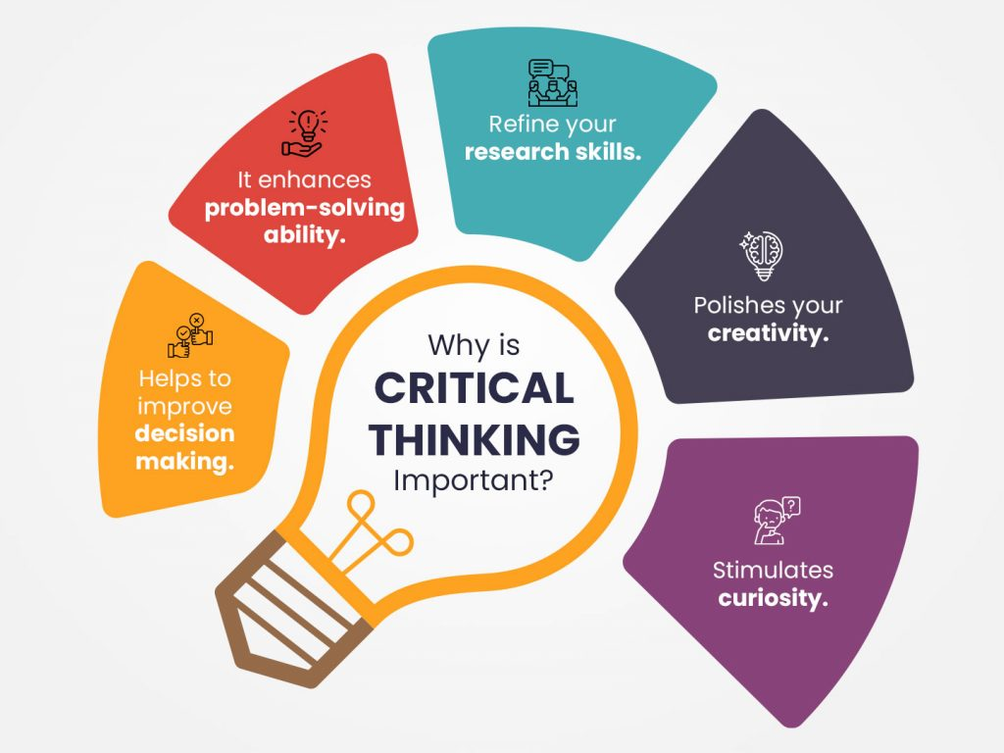

**Problem-solving :**

The process of finding solutions to difficult or complex issues:

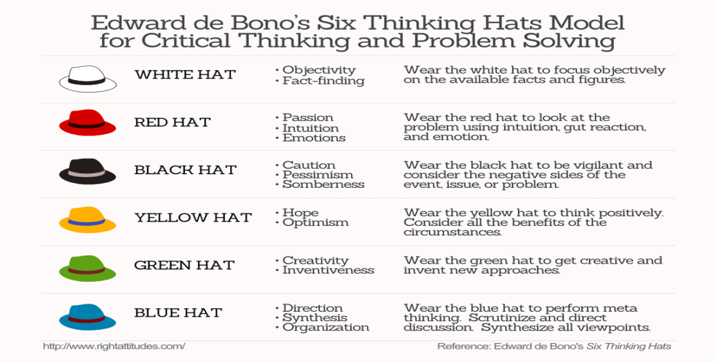

* Identify the issues. Be clear about what the problem is.
* Understand everyone’s interests
* List the possible solutions/options
* Evaluate the options
* Select the relevant option
* Evaluate

Universal Problem Solving Skills :

* Defining the Problem
* Brainstorming
* Analyzing
* Managing Risk
* Deciding
* Managing Emotions

**Conflict-Management**

Impact of Conflict :

* Affects your performance
* Impacts team environment
* Hampers growth
* Increases strife
* Encourages Groupism
* Lack of equal opportunities

Collaboration: widely used as a solution for Conflict Management

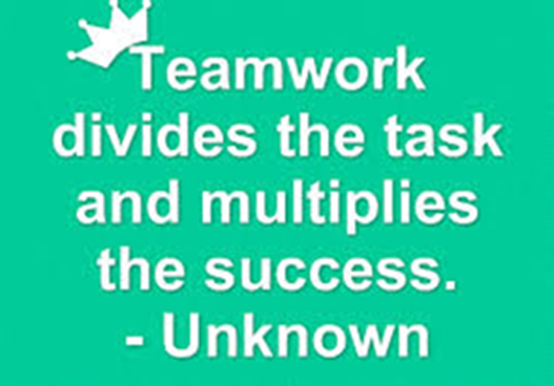

* Try to meet the needs of all involved
* Highly assertive
* Looking beyond self (co-operative)
* Everyone is important in the team. Acknowledge it.
* Good Bond within Team = less conflict
* Know your Team: Conduct health check for the team
* Address problems quickly: Do not sit on the problem
* Create a team charter: set guidelines for the team, implement it
* Create and enhance team culture: enhance positive team culture
* Build communication: Encourage transparent and positive communication
* Eye for detail: Be alert and pay attention



**Team-Dynamics :**

What is a TEAM ?

* Bond
* Understanding
* Building Trust
* Growth
* Overcoming Obstacles
* Resolving Conflicts
* Considering beyond self

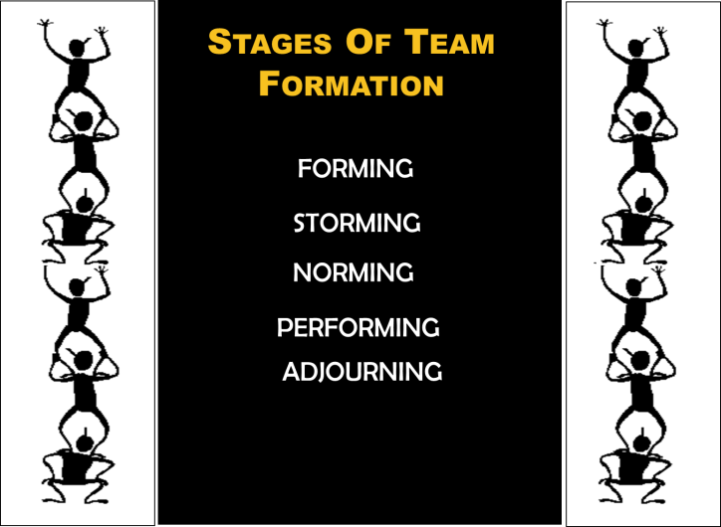

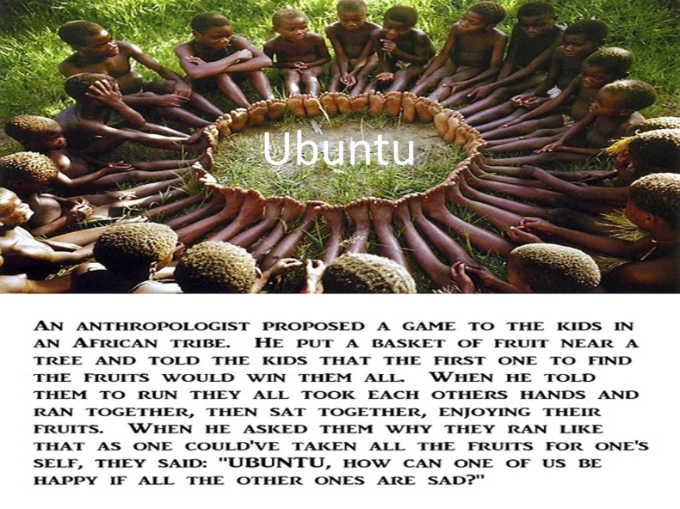

**Ubuntu** is an ancient African word meaning 'humanity to others'. It is often described as reminding us that 'I am what I am because of who we all are'.



* Listening
* Exchange of Ideas
* Cooperation
* Coordination
* Delegation
* Resolving Conflict